Observing Cloud Resources

*SRE Project Template*

# Categorize Responsibilities

| **Prometheus and Grafana Screenshots** | | |
| --- | --- | --- |
| Provide a screenshot of the Prometheus node_exporter service running on the EC2 instance. Use the following command to show that the system is running: sudo systemctl status node_exporter | | |
|  | | |
| **Host Metric**  **(CPU, RAM, Disk, Network)** | **Dashboard** | |
| *Disk* |  | |
| *Memory* |  | |
| *Network* |  | |
| *CPU* |  | |
| **Responsibilities** | | |
| 1. The development team wants to release an emergency hotfix to production. Identify two roles of the SRE team who would be involved in this and why. | | |
| *The release engineer and the monitoring engineer would be involved in this. The release engineer will ensure the best practices and launch checklists are adhered to. The monitoring engineer will monitor the resources post deployment, since this is an emergency hotfix straight into production.* | | |
| 2. The development team is in the early stages of planning to build a new product. Identify two roles of the SRE team that should be invited to the meeting and why. | | |
| *The system architect and the infrastructure engineer will be invited. Since this is a new product, their opinions regarding the system design and infrastructure required is both necessary and invaluable.* | | |
| 3. The emergency hotfix from question 1 was applied and is causing major issues in production. Which SRE role would primarily be involved in mitigating these issues? | | |
| *The release manager will be involved. He can go through the logs of the current release with the prior one and identify where the issue lies.* | | |

# 

# Team Formation and Workflow Identification

| **API Monitoring and Notifications** | | |
| --- | --- | --- |
| Display the status of an API endpoint: Provide a screenshot of the Grafana dashboard that will show at which point the API is unhealthy (non-200 HTTP code), and when it becomes healthy again (200 HTTP code). | | |
|  | | |
| Create a notification channel: Provide a screenshot of the Grafana notification which shows the summary of the issue and when it occurred. | | |
|  | | |
| Configure alert rules: Provide a screenshot of the alert rules list in Grafana. | | |
|  | | |

# 

# Applying the Concepts

| **Graph 1** | | |
| --- | --- | --- |
|  | | |
| 4a. Given the above graph, where does it show that the API endpoint is down? Where on the graph does this show that the API is healthy again? | | |
| *The endpoint status becomes non 200 at around 15.27. It becomes healthy again at 15:37.* | | |
| 4b. If there was no SRE team, how would this outage affect customers? | | |
| *Customers will not be able to access and use whatever it is they need to use.* | | |
| 4c. What could be put in place so that the SRE team could know of the outage before the customer does? | | |
| *Synthetic monitoring solutions like a blackbox exporter can be implemented. Such outages can be caught before it occurs that way. Also rigorous host monitoring can be implemented to catch symptoms of an impending outage. This way, before an outage occurs, issues can be caught and fixed.* | | |

| **Graph 2** | | |
| --- | --- | --- |
|  | | |
| 5a. Given the above graph, which instance had the increase in traffic, and approximately how many bytes did it receive (feel free to round)? | | |
| *The instance with ip: 10.0.0.68:9100 experienced the increase in traffic. There was an approximate increase of 3200 bytes.* | | |
| 5b. Which team members on the SRE team would be interested in this graph and why? | | |
| *The monitoring engineer, the system architect and infrastructure engineer will all be interested. If necessary, the system architect can recommend alternative technologies to prevent such rapid increase in traffic. The infrastructure engineer can ensure that load balancing is implemented correctly. The monitoring engineer was probably the one who caught this issue first.* | | |

# Other screenshots:

BlackBox Exporter:

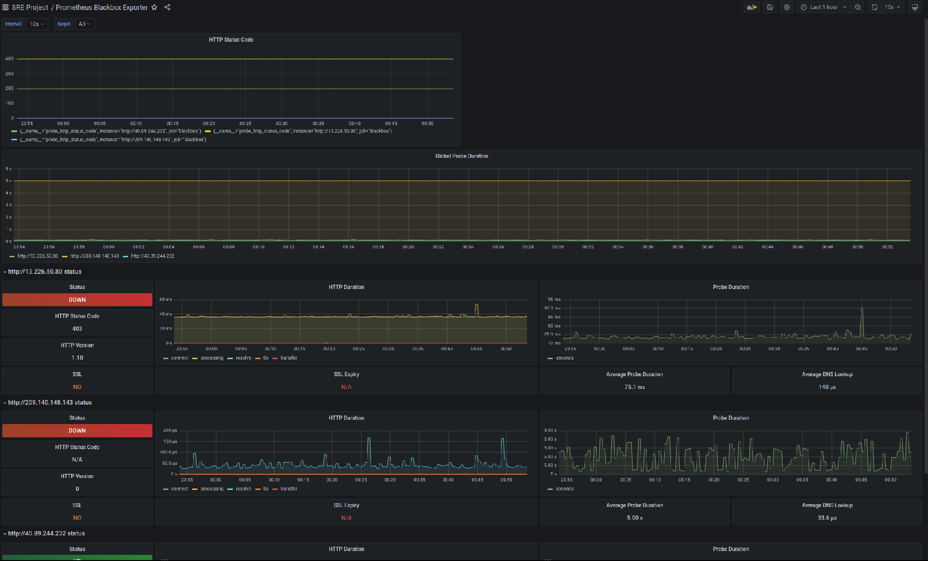

Alert triggered on Dashboard:



 